**Name:** Saeed Ahmed

**ID:** BIT-23F-018

**Class:** BSIT-3A

**Section: “**A”

**Lab Title:** Artificial Intelligence

**Instructor:** Madam Aqsa Umar

Task 1: Check if a Value is True or False  
In Python, any non-zero number or non-empty data structure is considered True, while zero, empty data structures, and None are False.  
  
python  
# Task 1: Check if a Value is True or False  
value = input("Enter a value: ")  
  
# Check if the value is True or False  
if value:  
    print("The value is True.")  
else:  
    print("The value is False.")

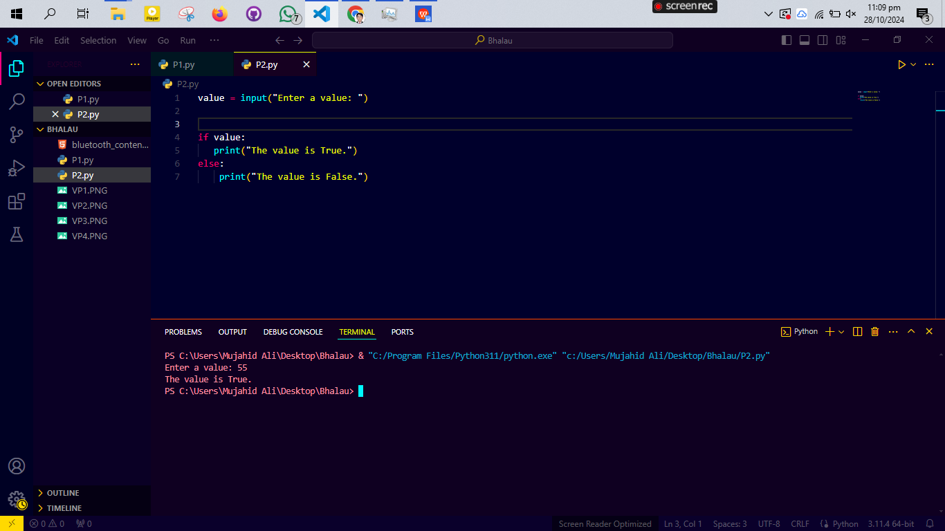

Task 2: Simple Calculator Using Operands  
This calculator performs addition, subtraction, multiplication, and division based on user input.  
  
python  
# Task 2: Calculator Program  
# Ask user for two numbers  
num1 = float(input("Enter the first number: "))  
num2 = float(input("Enter the second number: "))  
  
# Ask for the operation  
operation = input("Choose an operation (+, -, *, /): ")  
  
# Perform the calculation based on the chosen operation  
if operation == '+':  
    result = num1 + num2  
elif operation == '-':  
    result = num1 - num2  
elif operation == '*':  
    result = num1 * num2  
elif operation == '/':  
    if num2 != 0:  
        result = num1 / num2  
    else:  
        result = "Error: Cannot divide by zero"  
else:  
    result = "Invalid operation"  
  
print("The result is:", result)

Task 3: Examples of Different String Types ("", '', """ """)  
Python allows strings to be created using different types of quotes, allowing for flexibility in handling quotes within strings.  
  
python  
# Task 3: Different Types of Strings  
  
# Using double quotes ""  
string1 = "Hello, World!"  
print("String using double quotes:", string1)  
  
# Using single quotes ''  
string2 = 'Python programming is fun!'  
print("String using single quotes:", string2)  
  
# Using triple quotes """ """ for multiline strings  
string3 = """This is a  
multiline string,  
which spans multiple lines."""  
print("String using triple quotes:\n", string3)

